University at Buffalo Finance and Administrative Professionals

Professional Development Calendar & Resources

Internal Resources and Offerings

UB Human Resources / Organizational Development and Effectiveness Workshops:

- Become a Better Communicator
- Leverage Your DISC Communication Style
- Discover Your Strengths
- Build Positive Relationships
View these offerings and others on UB EDGE:
http://www.buffalo.edu/administrative-services/training/ubedge.html

UB Human Resources Supervisor Learning Forums:
- None currently scheduled; can review recordings of past forums here: http://www.buffalo.edu/administrative-services/training/training-catalog/human-resources/hr-virtual-workshops-archive.html#slf-servant
Career Coaching at UB: http://www.buffalo.edu/administrative-services/training/career-coaching.html

UB Collaborative Performance Management (CPM):
- Will begin again in Fall 2021.
- Submit interest through this link:
  - http://www.buffalo.edu/administrative-services/forms-catalog/hr/collaborative-performance-management-cpm-interest.html

External Resources and Offerings

College and Universities Professional Association for Human Resources (CUPA-HR)
- 2021 CUPA-HR ANNUAL CONFERENCE & EXPO: October 3-5, 2021 in National Harbor, Maryland
- View other events and workshops on their website: https://www.cupahr.org/
  - Click “Events” tab
National Association of College and University Business Officers (NACUBO):
- Higher Education Accounting Forum held annually in April
  - Link to 2021 event: https://www.nacubo.org/Events/2021/2021-Higher-Education-Accounting-Forum
- Annual meeting held annually in July

  - Link to 2021 event: https://www.nacubo.org/Events/2021/NACUBO-2021-Annual-Meeting
- Budget and Planning Forum to be held annually in September; 2021 event on Sept. 13, 14, 17
  - Link to 2021 event: https://www.nacubo.org/Events/2021/2021-Planning-and-Budgeting-Forum
- View others events and workshops on their website: https://www.nacubo.org/Events

Eastern Association of College and University Business Officers (EACUBO):
- EACUBO Spring Workshops held annually in March
  - Link to 2021 event: https://www.eacubo.org/en/Programs-and-Events/Workshop-2021/Program-Detail
- Annual Meeting held in October; 2021 event on Oct. 31-Nov. 2.
  - https://www.eacubo.org/Programs-and-Events/Annual-Meeting-2021

Southern Association of College and University Business Officers (SACUBO):
  - College Business Management Institute (CBMI) held annually in July
  - Link to 2021 event: https://www.sacubo.org/en/Professional-Development/CBMI

Daily/Weekly Newsletter Subscription Recommendations

- InsiderHigherEd
  - https://www.insidehighered.com/content/sign-inside-higher-eds-newsletters
- The Chronicle of Higher Education
    - Subscribe to “Daily Briefing”, follow steps below:
Step 1: Sign-In
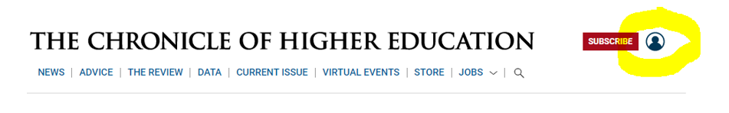

Step 2: Click on Account Icon, Select “Newsletters”

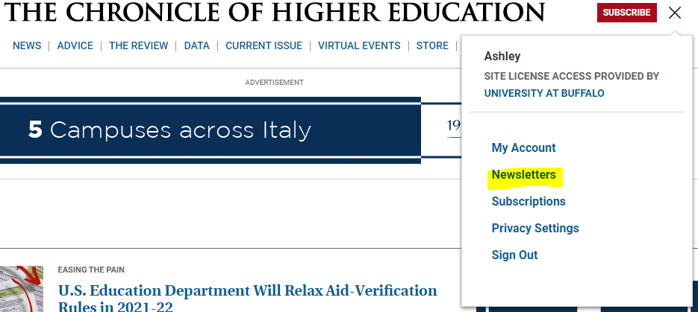

Step 3: Subscribe as desired

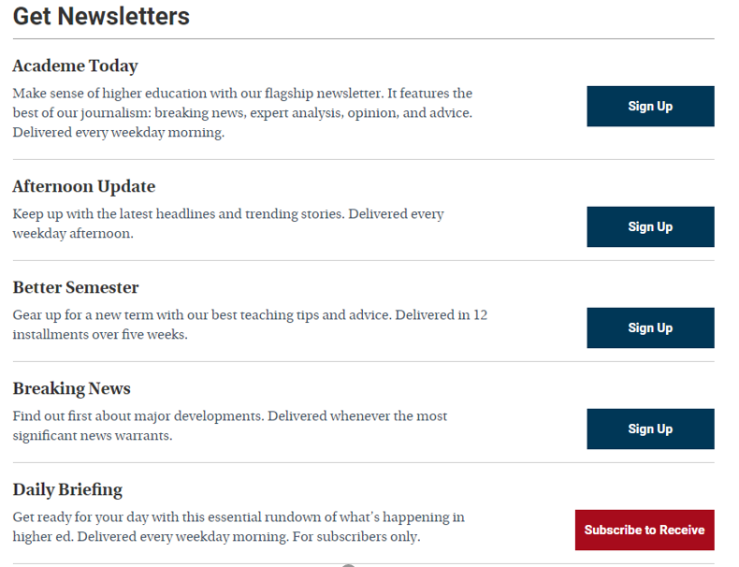

Suggestion: Consider other internal organizations/associations you are affiliated with (not necessarily directly involved with); enroll in listservs within those offices/entities to expand knowledge base and perspective of greater holistic understanding of university operations.

Educational Advisory Board (EAB):
- If you haven’t yet created a username/password:
  - Go to eab.com; top left of homepage hover over “Member Log-In”, select “New User”.
  - Complete registration page, click submit to obtain confirmation code and log-in information to EAB website.
- This will grant you access to membership forums (Academic Affairs, Business Affairs, Student Affairs), executive summaries and studies, resource centers and toolkits, etc.

